1. **SELECT**: Retrieve all columns from the Doctor table.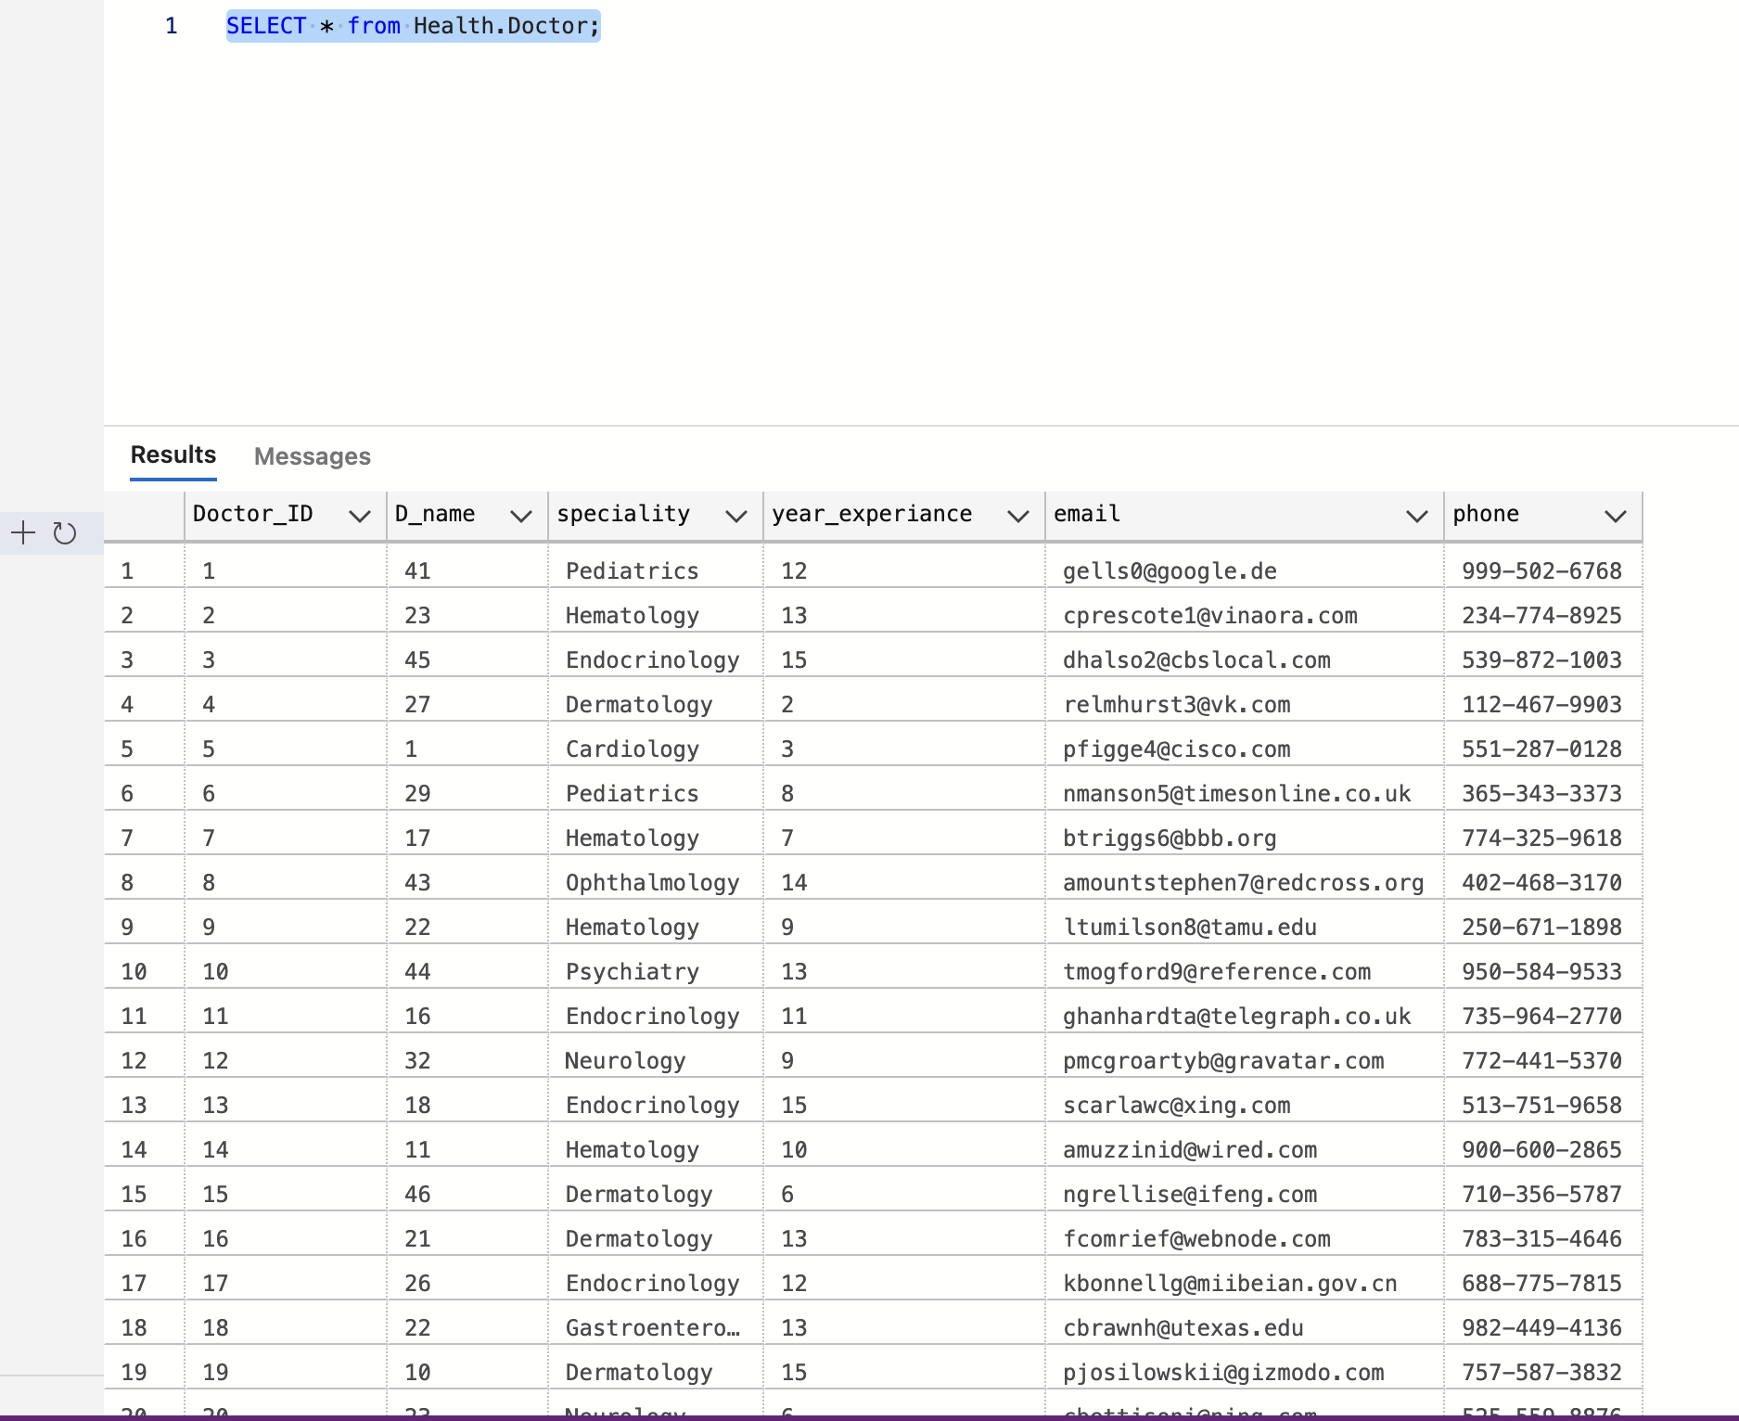
2. **ORDER BY**: List patients in the Patient table in ascending order of their ages.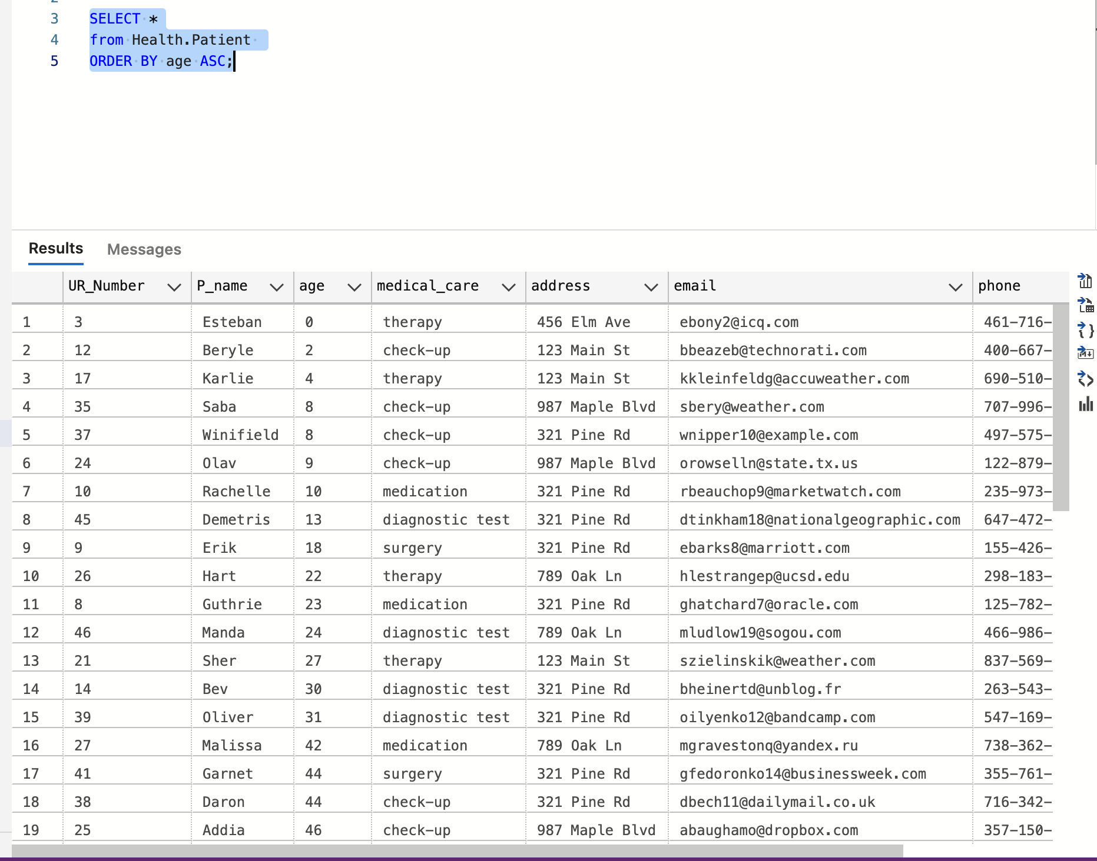
3. **OFFSET FETCH**: Retrieve the first 10 patients from the Patient table, starting from the 5th record.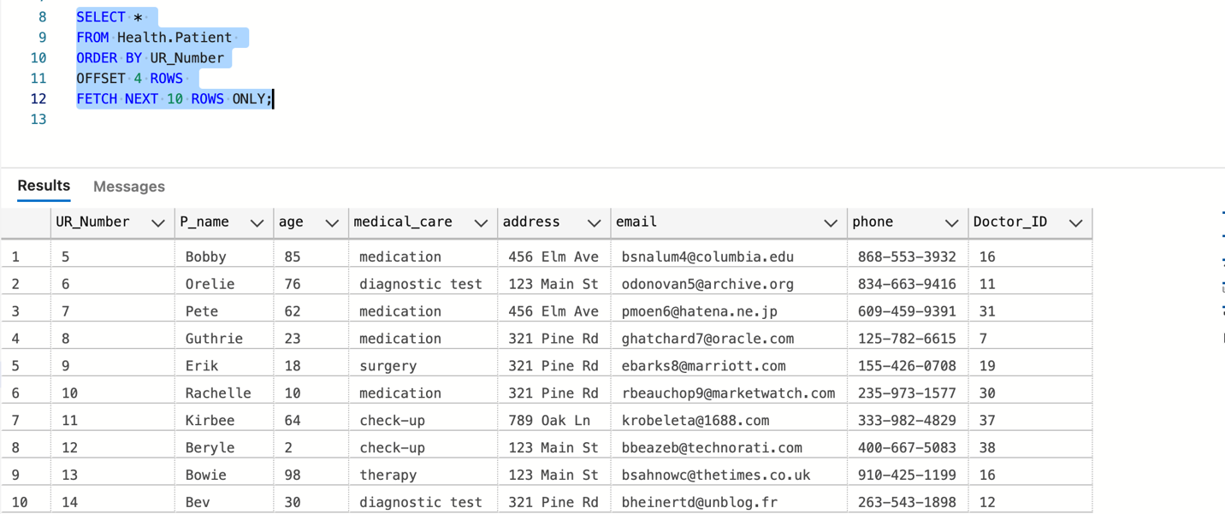
4. **SELECT TOP**: Retrieve the top 5 doctors from the Doctor table.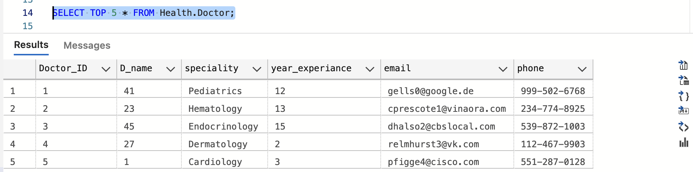
5. **SELECT DISTINCT**: Get a list of unique address from the Patient table.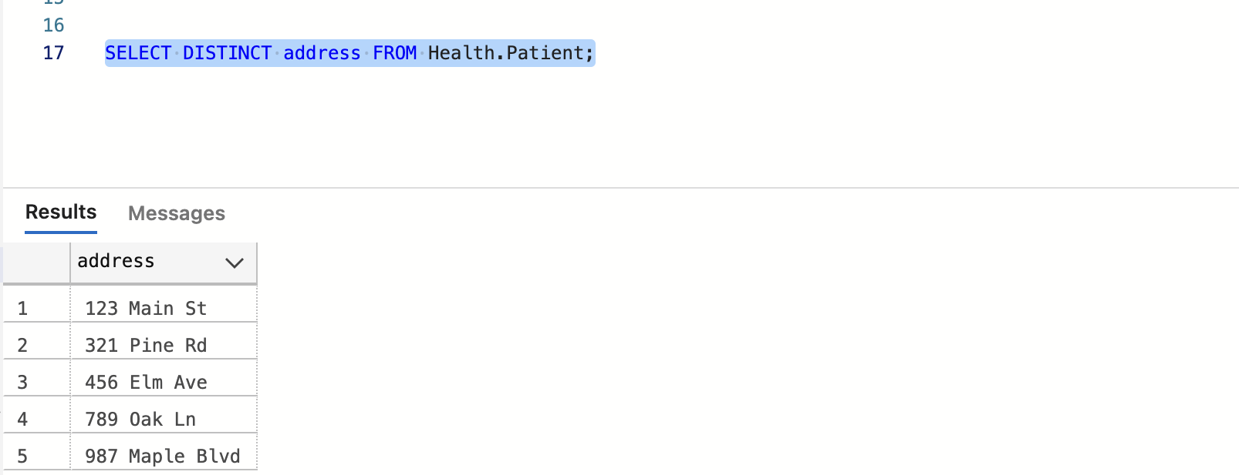
6. **WHERE**: Retrieve patients from the Patient table who are aged 25.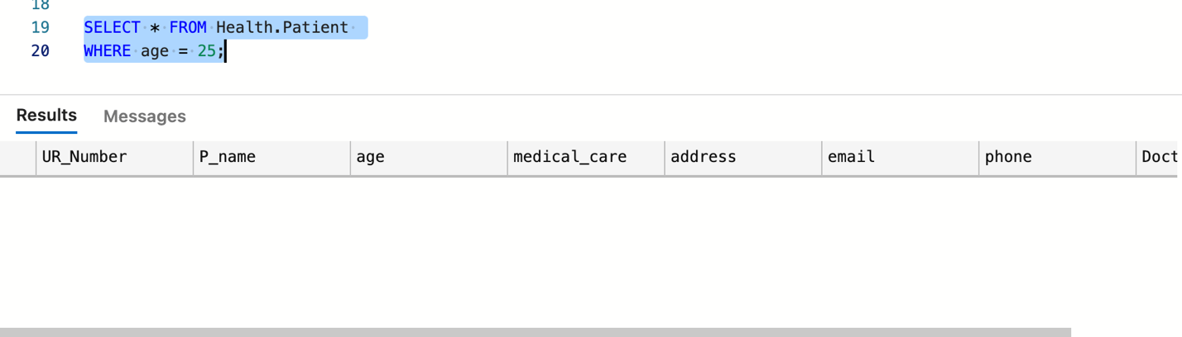
7. **NULL**: Retrieve patients from the Patient table whose email is not provided.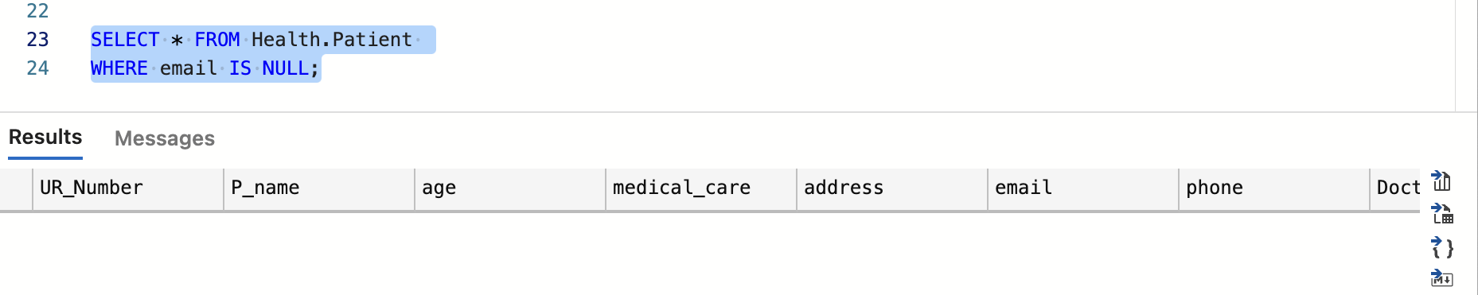
8. **AND**: Retrieve doctors from the Doctor table who have experience greater than 5 years and specialize in 'Cardiology'.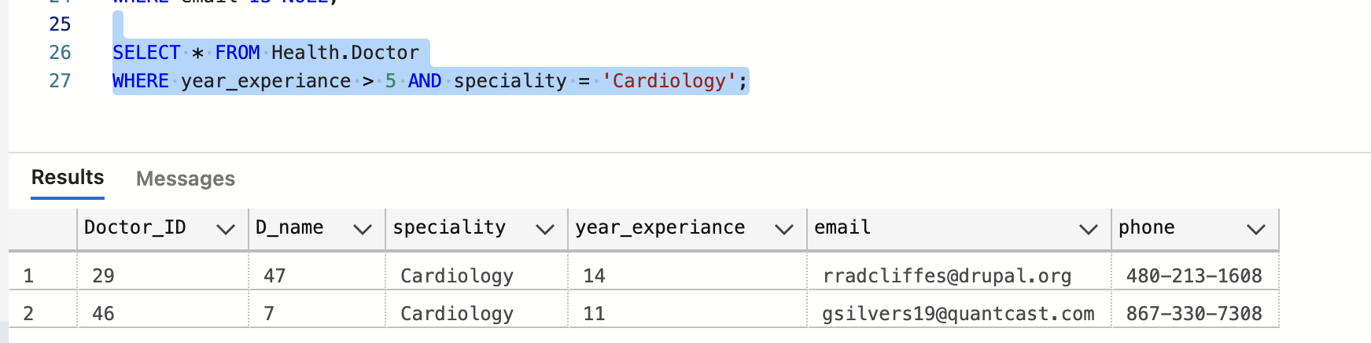
9. **IN**: Retrieve doctors from the Doctor table whose speciality is either 'Dermatology' or 'Oncology'.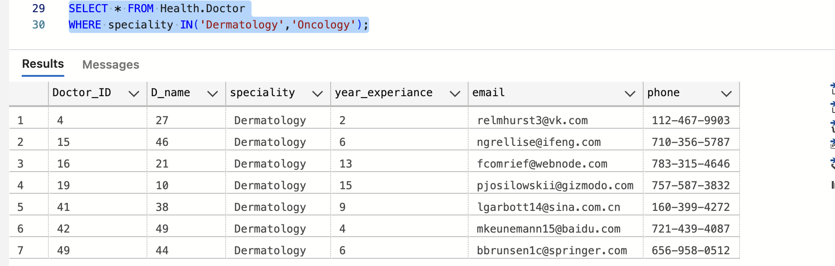
10. **BETWEEN**: Retrieve patients from the Patient table whose ages are between 18 and 30.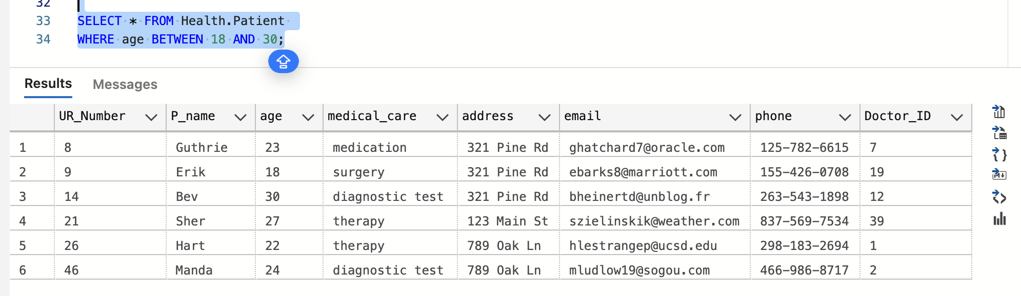
11. **LIKE**: Retrieve doctors from the Doctor table whose names start with 'Dr.'.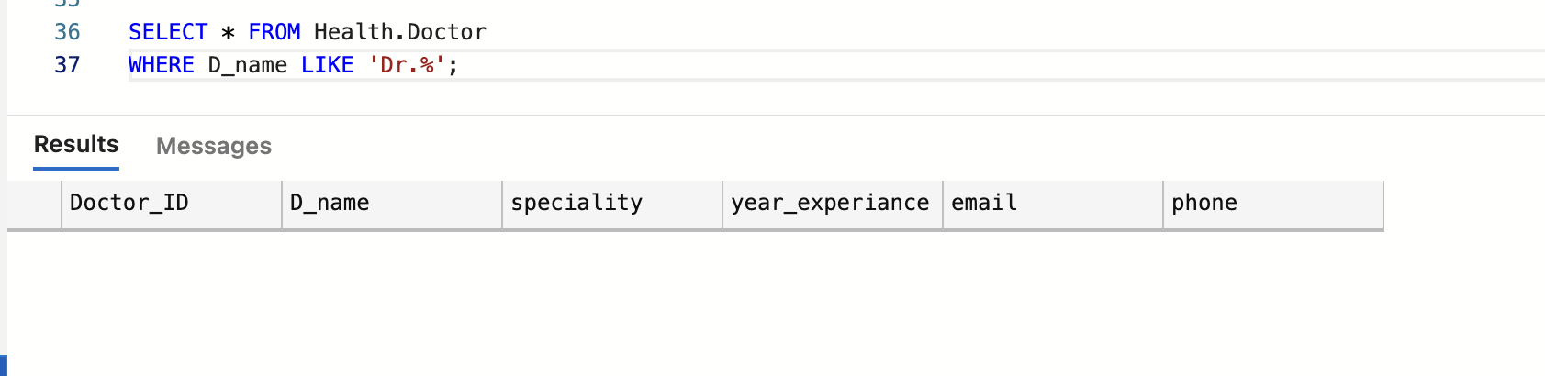
12. **Column & Table Aliases**: Select the name and email of doctors, aliasing them as 'DoctorName' and 'DoctorEmail'.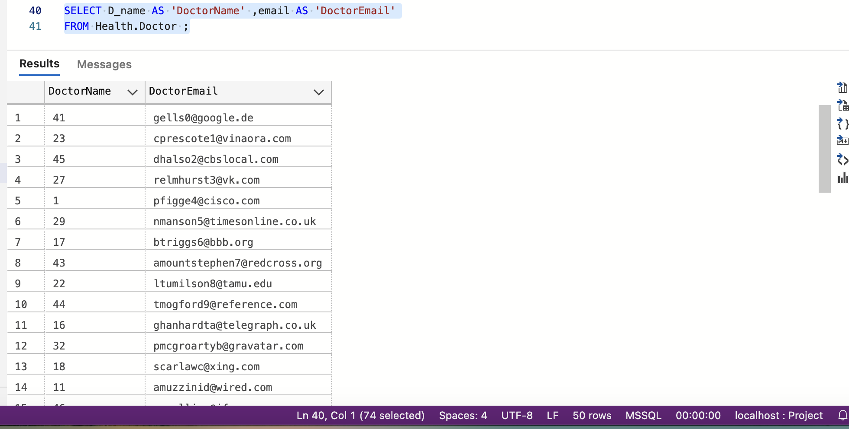
13. **Joins**: Retrieve all prescriptions with corresponding patient names.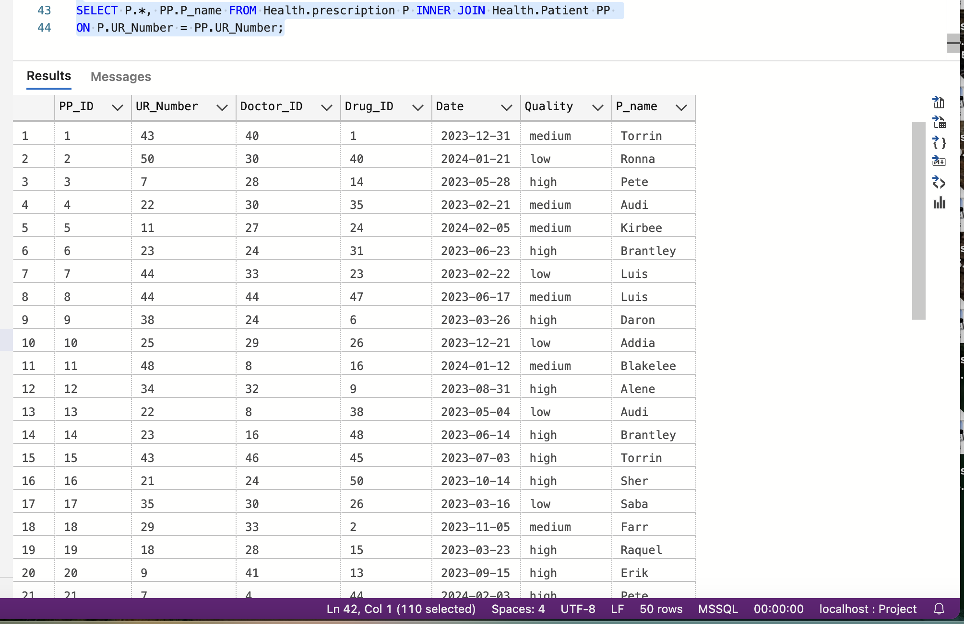
14. **GROUP BY:** Retrieve the count of patients grouped by their cities.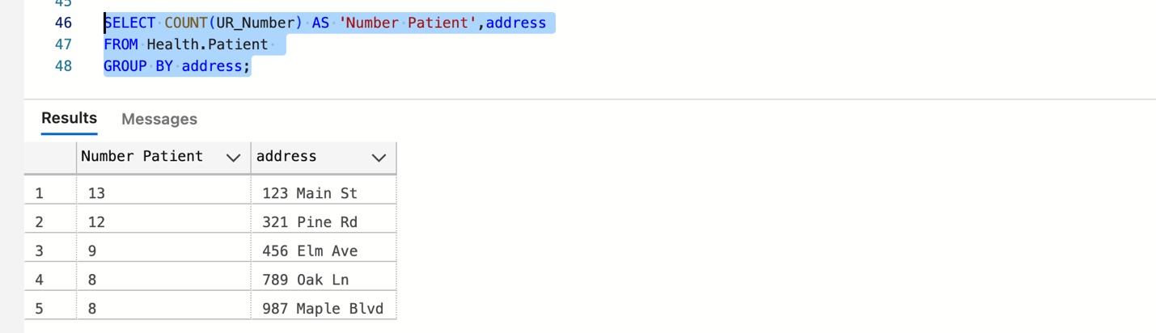
15. **HAVING:** Retrieve cities with more than 3 patients.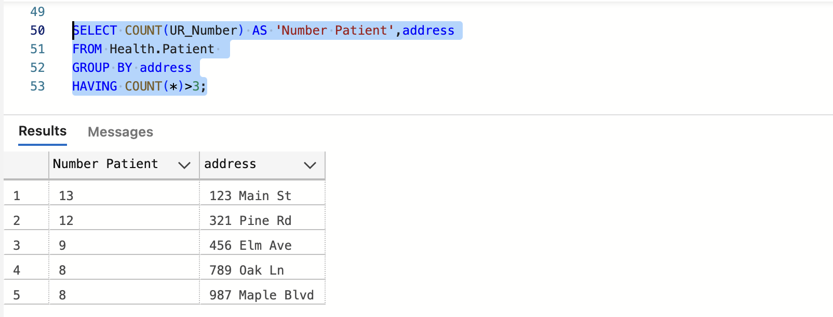
16. **GROUPING SETS:** Retrieve counts of patients grouped by cities and ages.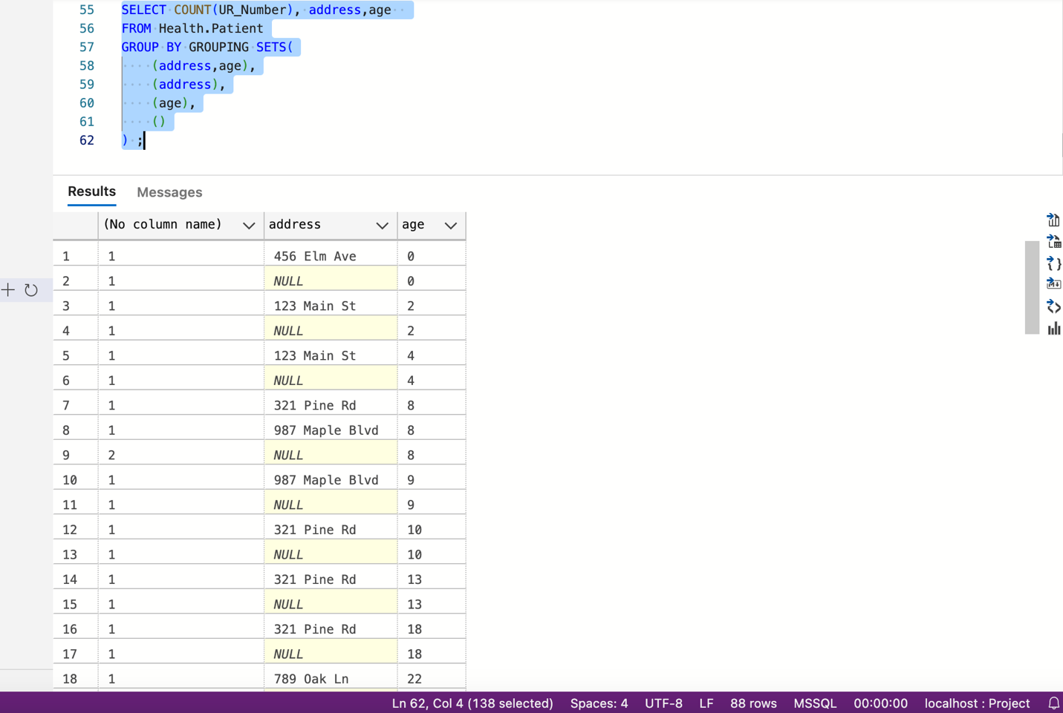
17. **CUBE:** Retrieve counts of patients considering all possible combinations of city and age.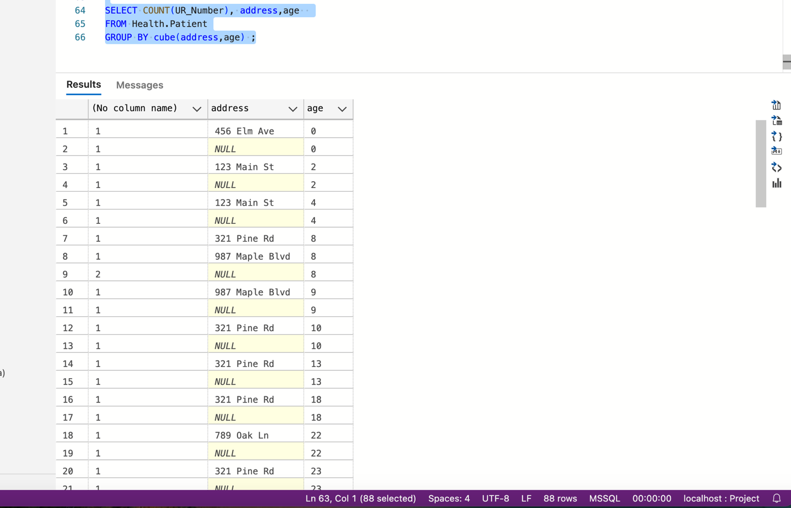
18. **ROLLUP:** Retrieve counts of patients rolled up by city.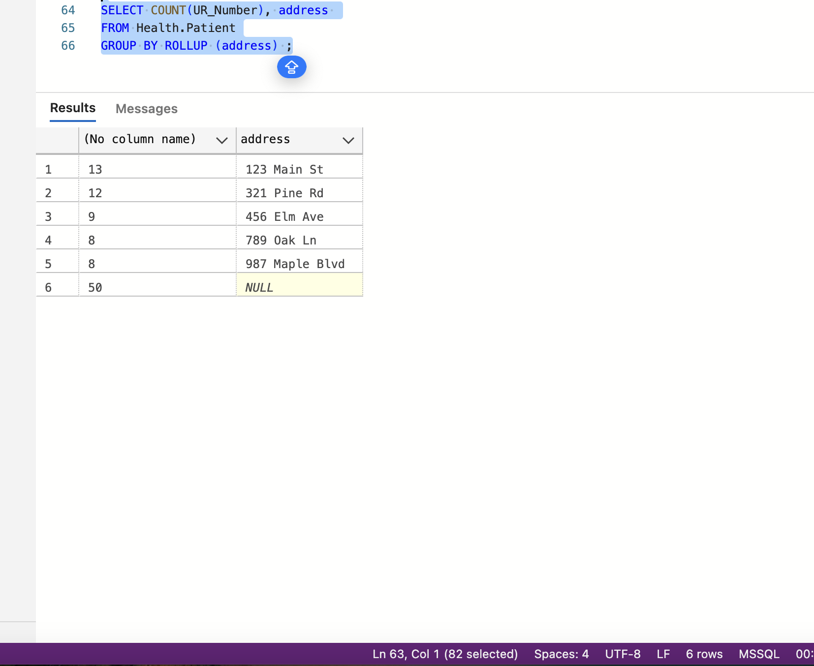
19. **EXISTS**: Retrieve patients who have at least one prescription.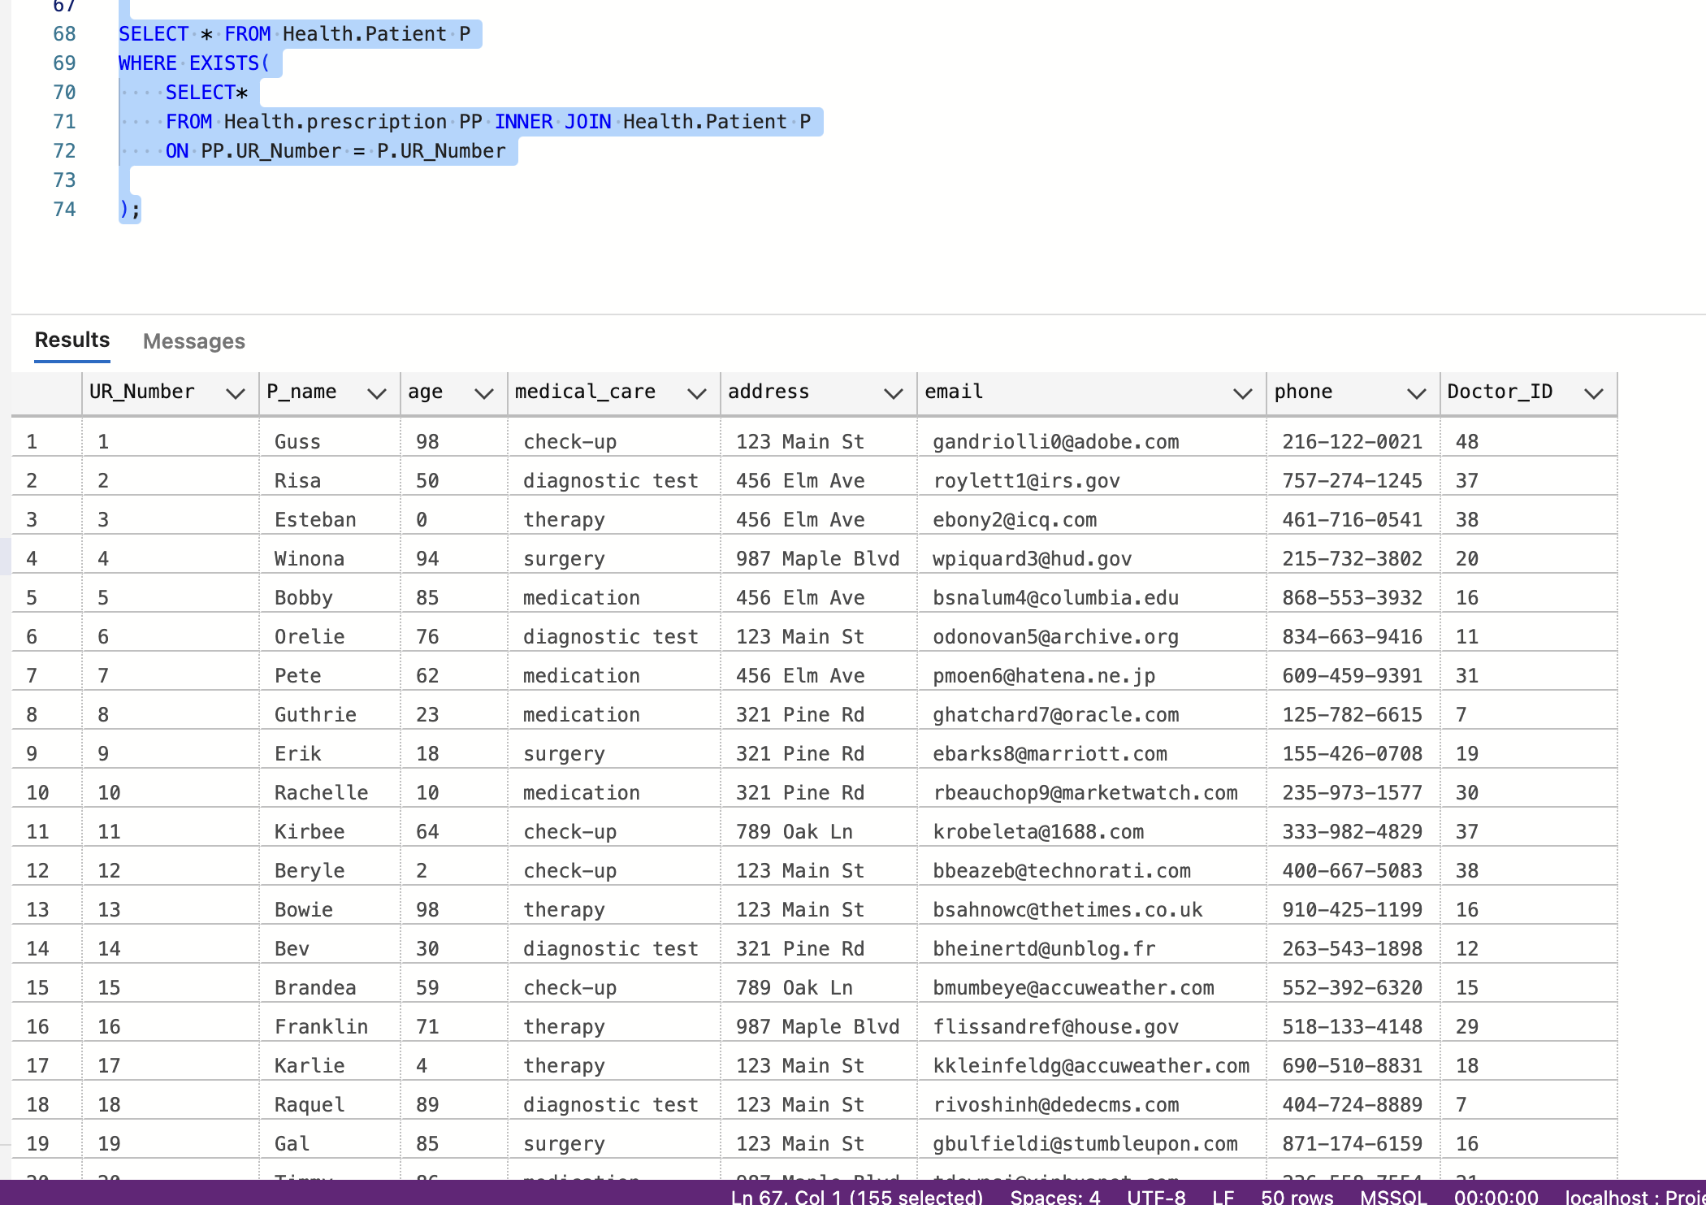
20. **UNION:** Retrieve a combined list of doctors and patients.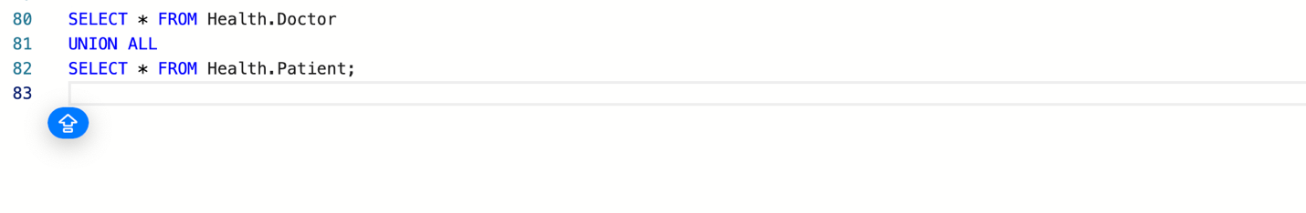
21. **Common Table Expression (CTE):** Retrieve patients along with their doctors using a CTE.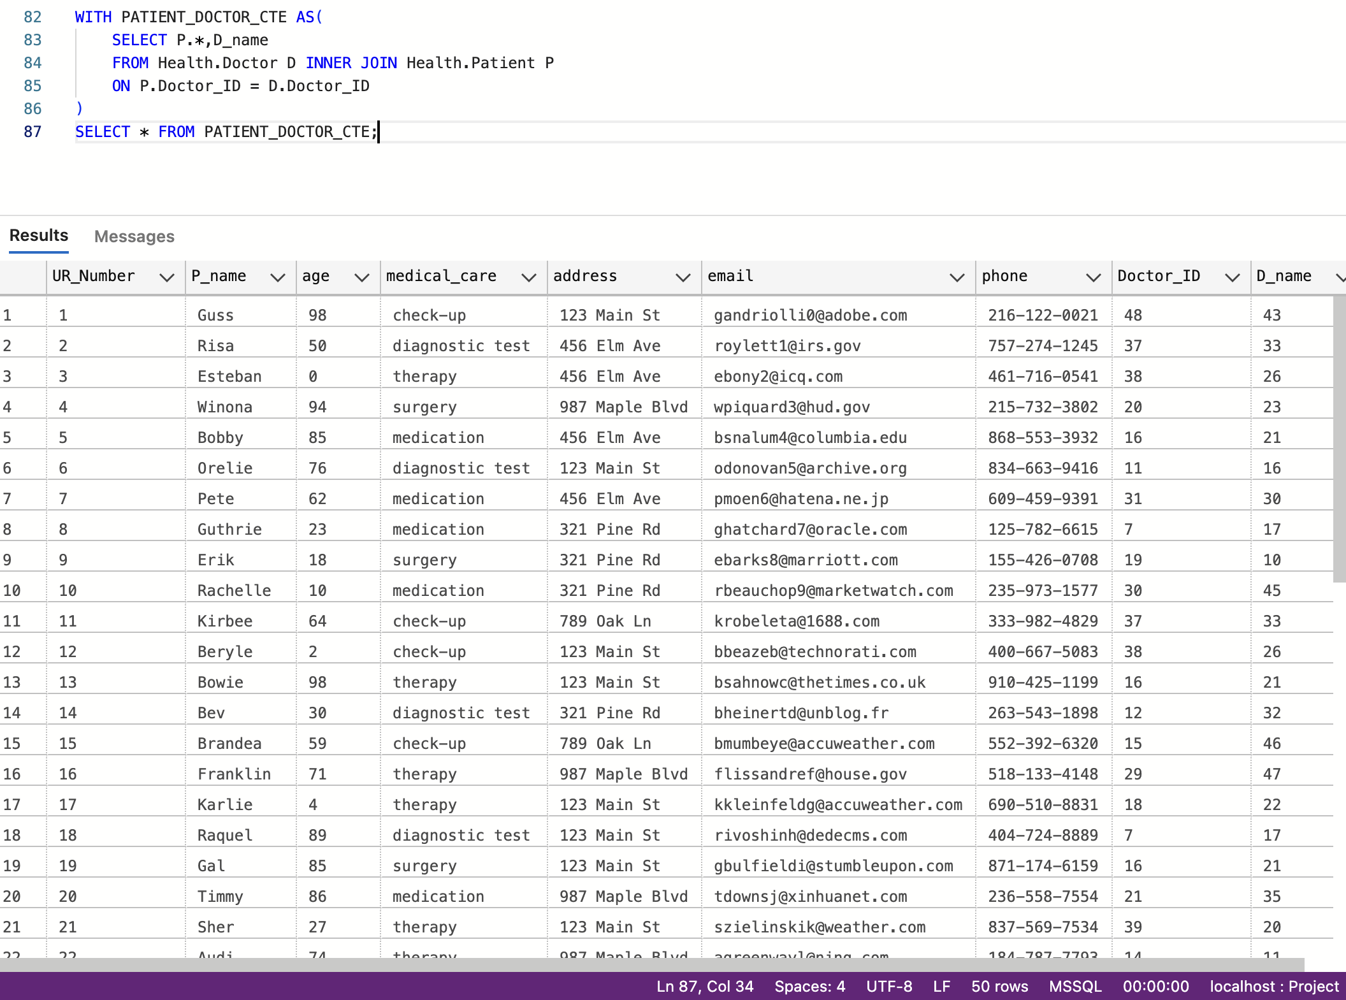
22. **INSERT:** Insert a new doctor into the Doctor table.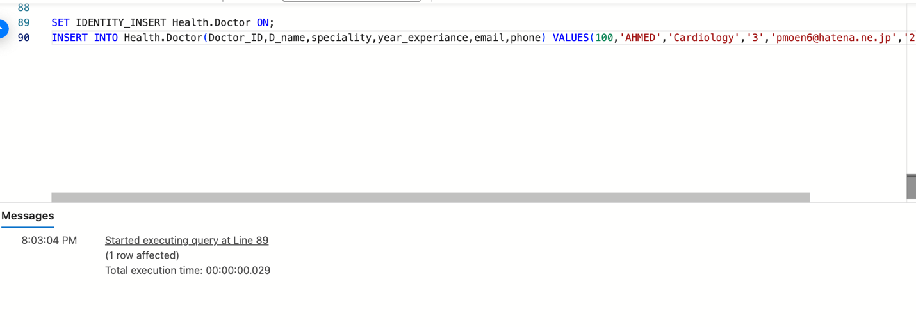
23. **INSERT Multiple Rows:** Insert multiple patients into the Patient table.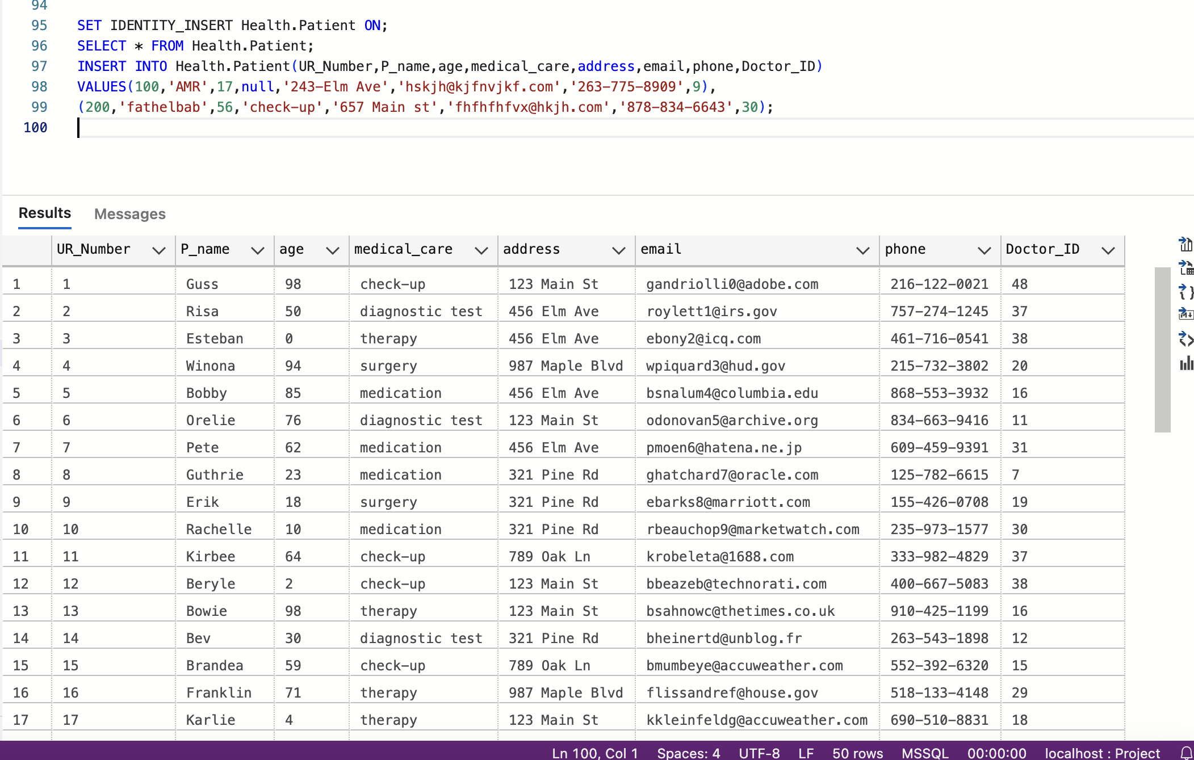
24. **UPDATE:** Update the phone number of a doctor.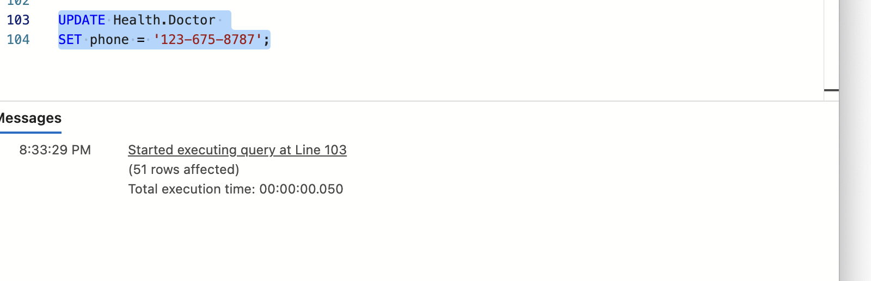
25. **UPDATE JOIN:** Update the city of patients who have a prescription from a specific doctor.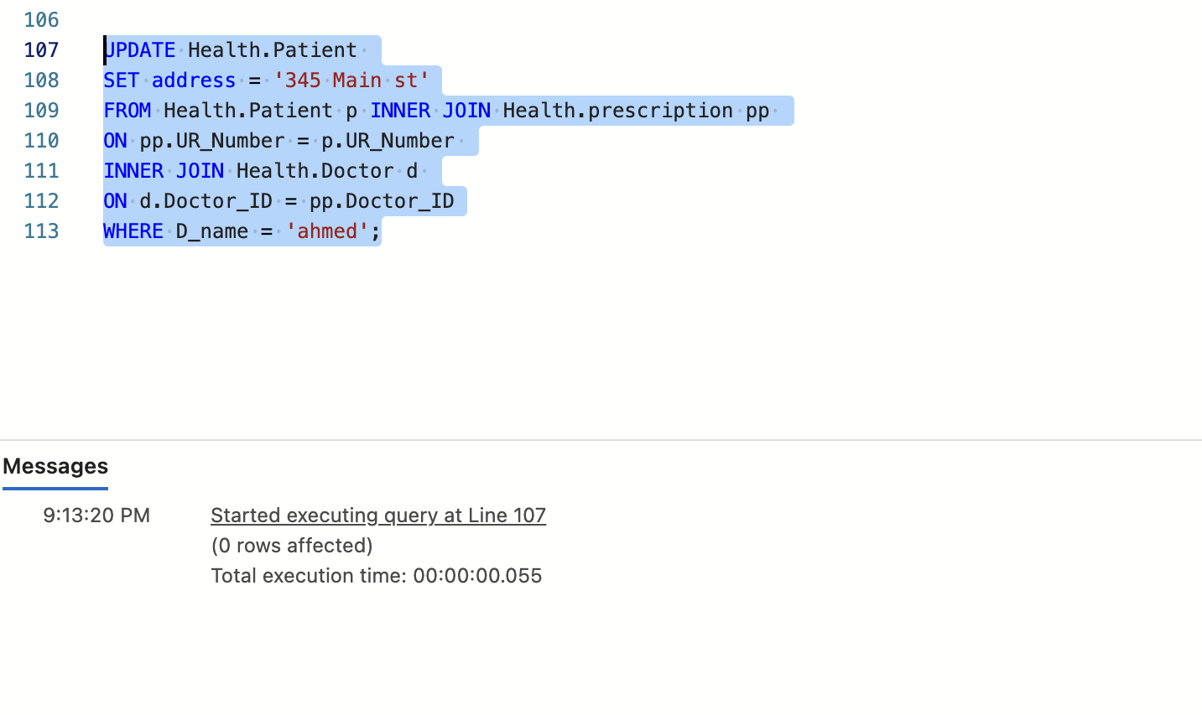
26. **DELETE:** Delete a patient from the Patient table.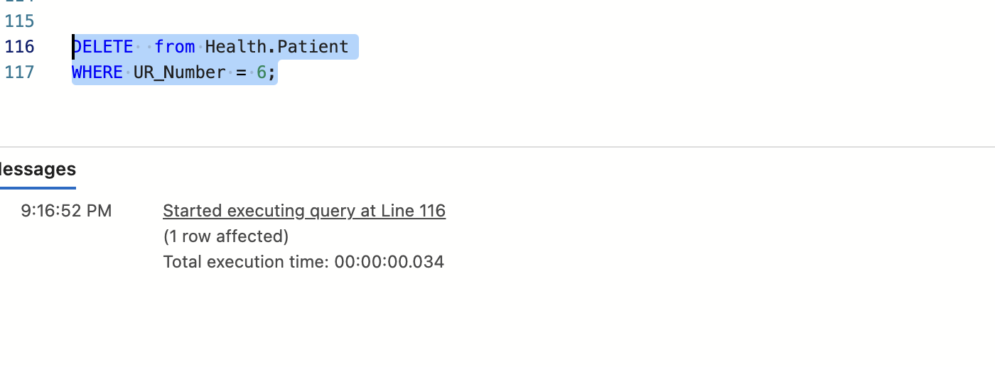
27. **Transaction:** Insert a new doctor and a patient, ensuring both operations succeed or fail together.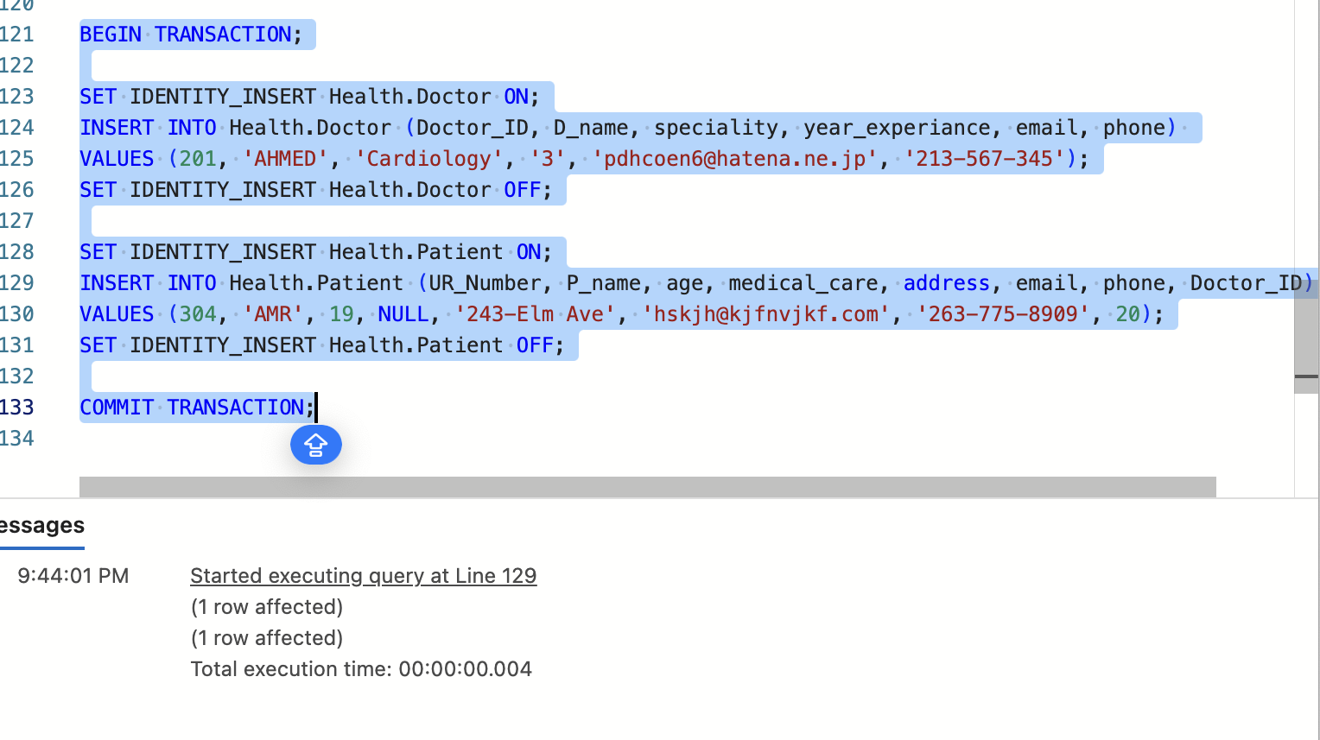
28. **View:** Create a view that combines patient and doctor information for easy access.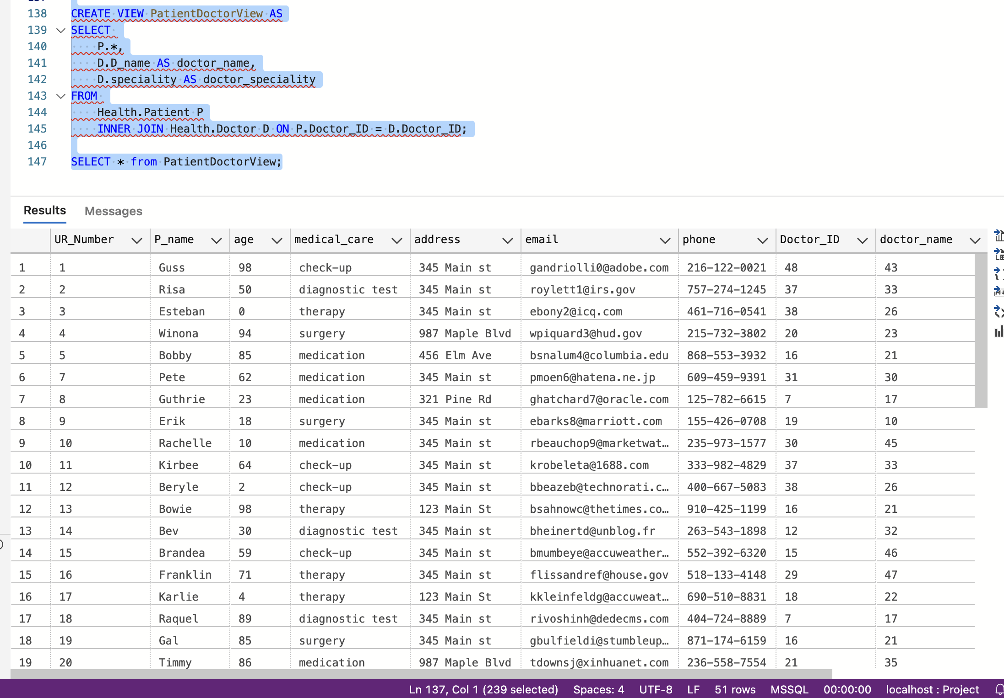
29. **Index:** Create an index on the 'phone' column of the Patient table to improve search performance.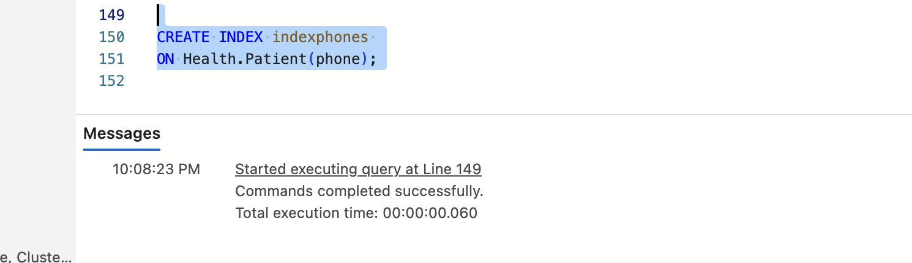
30. **Backup:** Perform a backup of the entire database to ensure data safety.